A000-AFR-Burkina Faso-Mossi-Biga-Figurine-Female-Leather and Wood-1st half 20th c

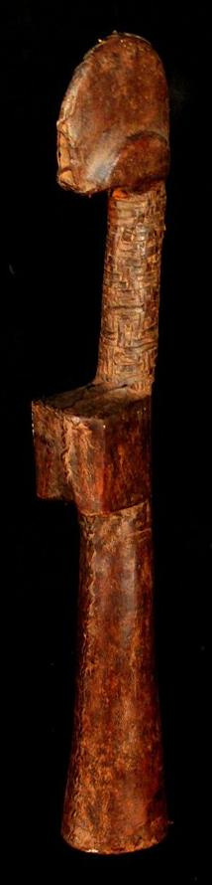

**Fig. 1.** Burkina Faso-Mossi-Biga-Figurine-Female-Leather and Wood-1st half 20th c

**Case No.: 6**

**Accession No.**

**Formal Label:** Burkina Faso-Mossi-Biga-Figurine-Female-Leather and Wood-1st half 20th c

**Display Description:**

*Biga* means child and is an educational object for girls among the Mossi of Burkina Faso to prepare the girls for their future rolls as mothers. Although the primary use of these *biga* is for education, some also hold importance for adult women, and often times a woman will bring her *biga* when she departs her father's home to live with her new husband. In this case the roll of the figure becomes one of fertility.

*Biga* were carved from wood and could be covered in pieces of leather as in this example. The arms and legs are not represented but the doll still bears breasts to symbolize motherhood. Over the years, the girl will carry and hold the doll and anoint it with butter and oils. Most *biga* figurines are eventually passed down or inherited from a family member. In this case they represent the female family lineage. The figurines are covered with palm oil and would be perceived to have magical protection.

**LC Classification:** NB1255.B92

**Date or Time Horizon:** 1st half 20th c

**Geographical Area:** Ouahigouya, Burkina Faso.

**Map:**

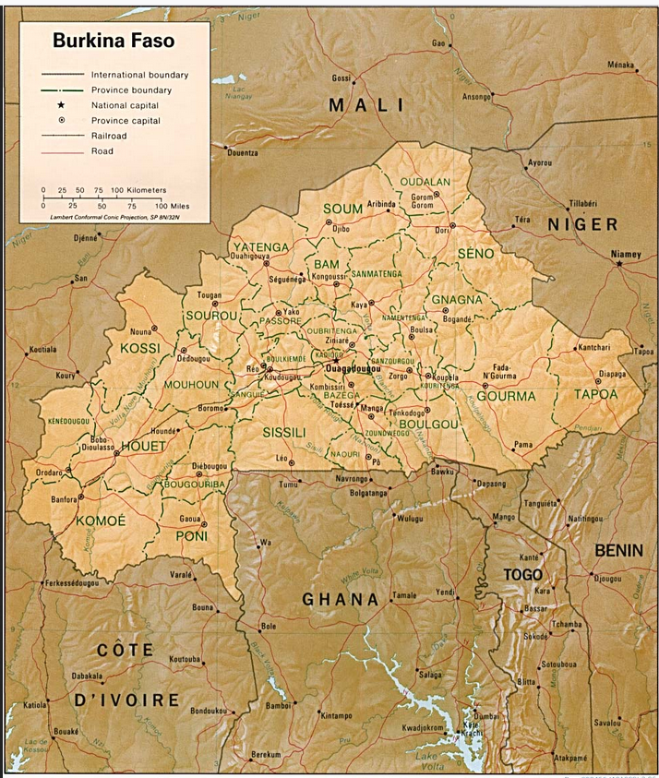

Fig. 4. Map of Benin. From <https://www.africa.upenn.edu/CIA_Maps> Burkina Faso.

**GPS coordinates:** 13º34'0.57" N 2º24'39.57" W

**Cultural Affiliation:** Mossi, Biga

**Media:** wood and leather

**Dimensions:** H 13.77 inches,

**Weight:** 0.599 pounds

**Condition: original**

**Provenance:** Ouahigouya, Burkina Faso

**Discussion:**

The aniconic aspect of *biga* figurines is also important because they represent not an individual's appearance but the abstract identity of the maternal lineage of the local group. **The shape of the head reflects the tribal origin, with hair shaped in a special crest and the wood marked with facial scars or protuberances.** As such they are carriers of both familial and maternal identities. This is one aspect of how, in a preliterate society, historical memory can be passed down the generations.

**References:**

Brisset, Claire and Galerie Flak. 2007. *Biga: poupées de fertilité mossi*. Paris: Galerie Flak, Enfance de l'art.